In this lab, what is required is to remove salt and pepper noise from an image, so I used skimage library to do the following:

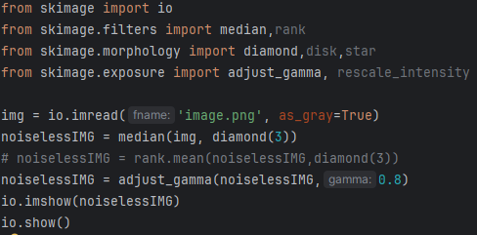

I first loaded the image using io.imread() and added another parameter of as_grey to always let the image be grayscale regardless of image type (png or jpg)

Then I used the median function from skimage.filters to return the local median for each pixel in an image, the shape used was diamond(3) which provided the best answer compared to other shapes (other shapes used: disk, square, rectangle, star, octagon each with different values)

Diamond 3 VS Disk 3

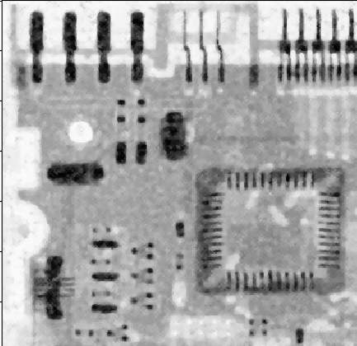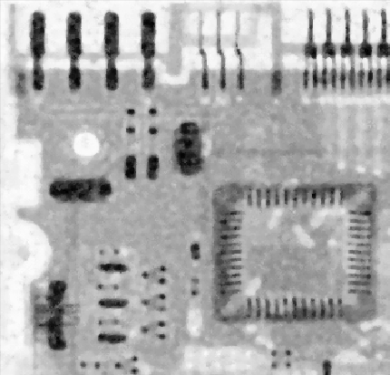

Alternatively, we can instead use rank.mean to get the local mean for each pixel in a image, the shape used for that was also diamond(3) for the same reason.

Gamma function was used to increase brightness of the picture as the image in the assignment is a bit brighter so I thought increasing brightness would affect the clarity of the image which it did.

Without Gamma Adjustment VS With Gamma Adjustment (0.8)

